**State and setState**

**Why we use state without using props?**

State is the most core and important concept in the react

🡪 because when we use props then we cannot change the value of props and 🡪 when we use state then we can change the value of it and use

**How we can use state?**

1st of all create a state.js file in the Component

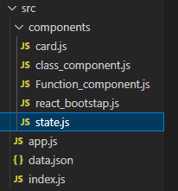

2nd then create a class using rcc command

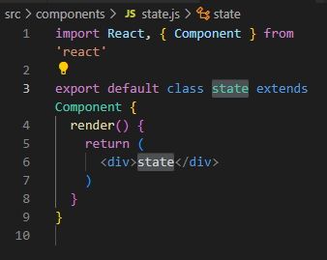

After that import the state.js in the app.js



Then create constructor of state using rconst

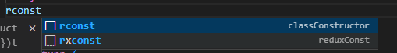

After that appears

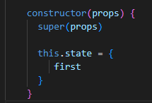

After that in this.state create count:0 and create a a button using onclick function and write the code

Create a class component

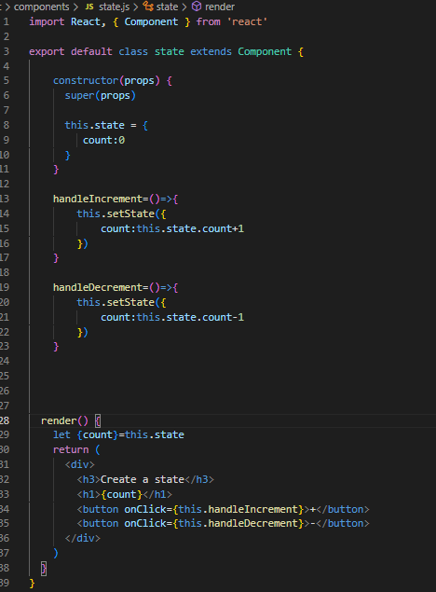

Here we use setState to setthe value

Create heading and button tag and also onClick function

Destructuring the state

Declare a name and value

Then create a constructor using rconst

If we want to disable something then we can do



Here we use ternary operator. That means the decrement doesn’t work if the count is 0.

After completing the state,

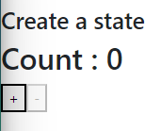

When we click + then the count is increasing and when the count is 0 then the - is disabled.